6.4 LEARNING OUTCOMES PORTFOLIO (TWO OUTCOMES)
SONG HOON KO
ASCI 254
EMBRY RIDDLE UNIVERSITY
SUSAN BAILEY-SCHMIDT
5/8/2017

Learning Outcome #1. Evaluate the roles and influence of key individuals, institutions, and organizations in the development and regulation of commercial aviation
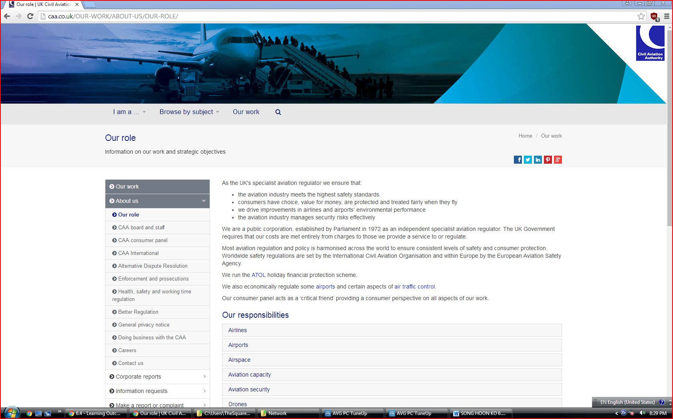

Artifacts 2
Roles of institution
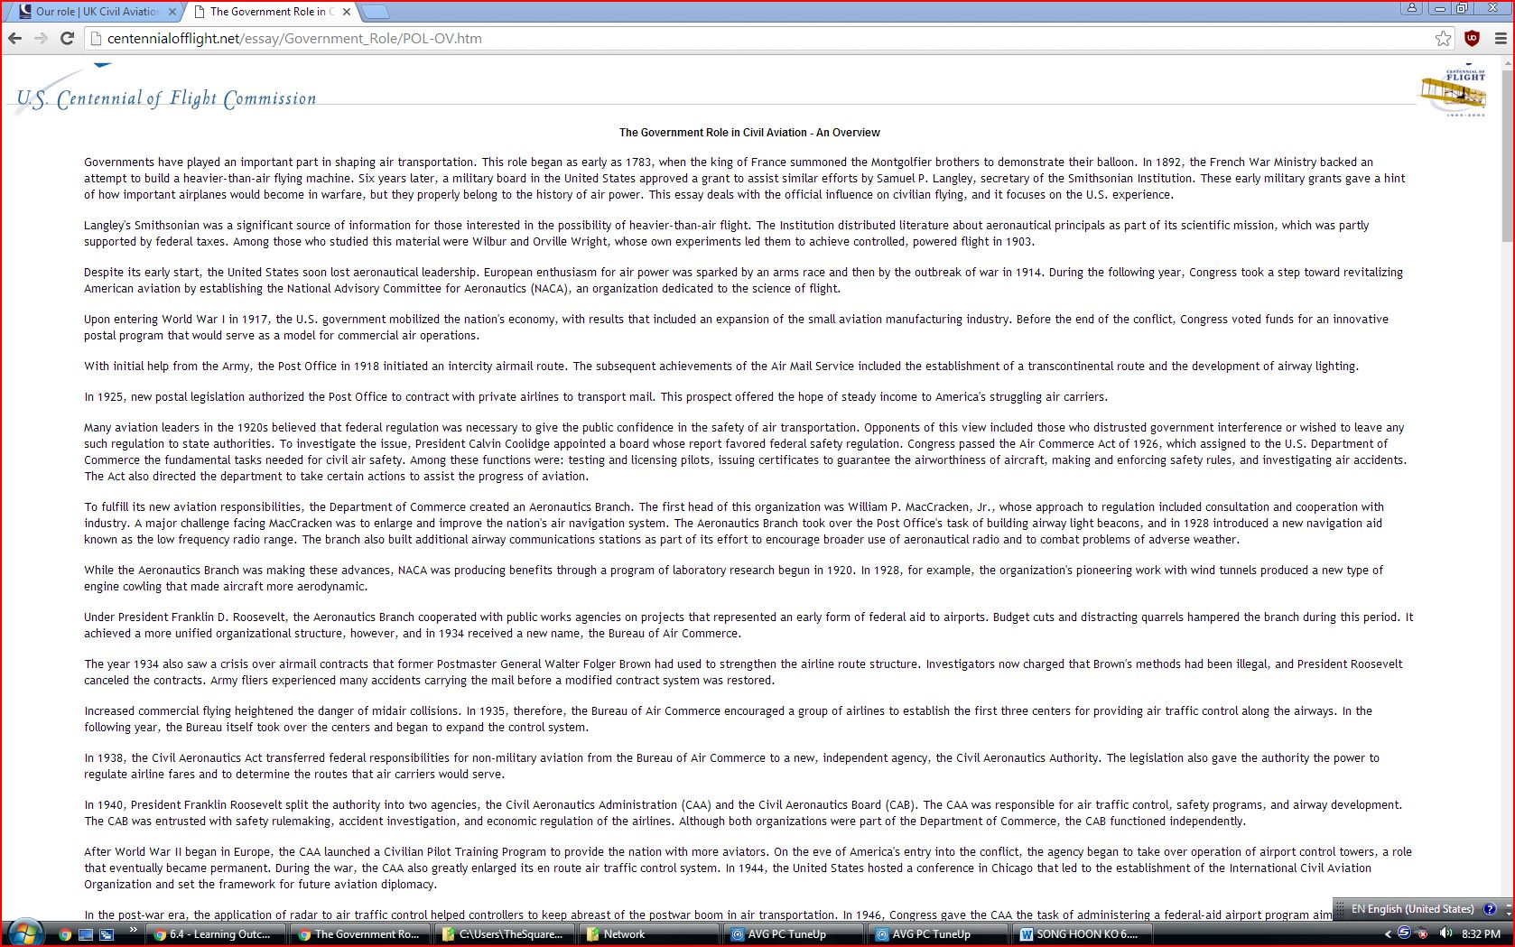
Artifact 3. Role of organization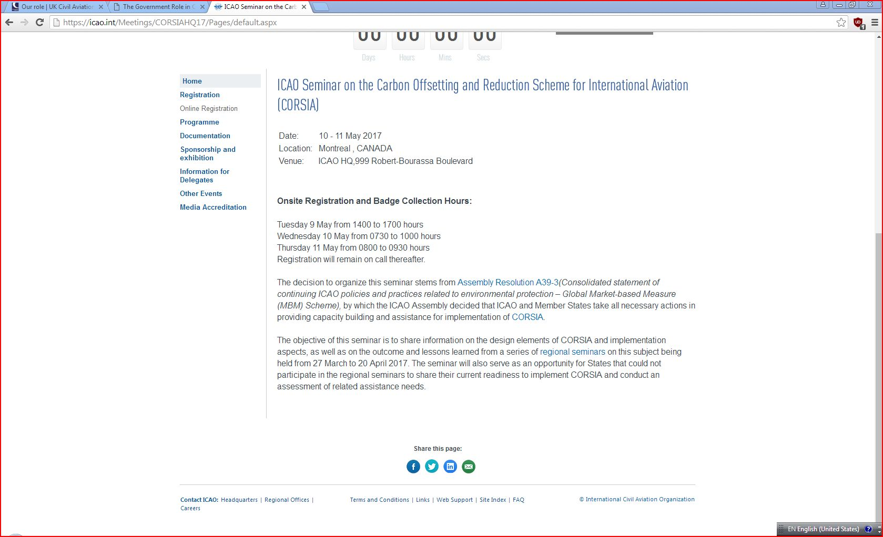
Rationale- These artifact discuss the key roles played by key players in the industries. These include individuals, institution such as government and other commission bodies, there is also ICAO which holds seminars to try and mitigate the negative impact on the usage of aviation. Some of these negative impacts include pollution of the environment such as releasing of green-house gases such may cause effects such as global warming. The ICAO held a seminar which was aimed and helping in offsetting the release of carbon and how they can mitigate the impacts. On the role of government, she come up with bodies that regulate the aviation industries such as U S Centennial of Flight Commission. The aim is to shape the air transport and this role started in 1783 to reduce danger caused from this industries. The aim to control the industries to ensure it strictly follow the role set and this will reduce the accidents and other dangers in the industries such as accidents which have great negative. These negative include high death and injuries.
Learning Outcome #2. Explain the general contextual elements influencing aviation policies and regulation, including technology, markets, group interests, and politics.
Artifacts 1. Government Regulations, Challenges, Impact On Airline Business Revenues
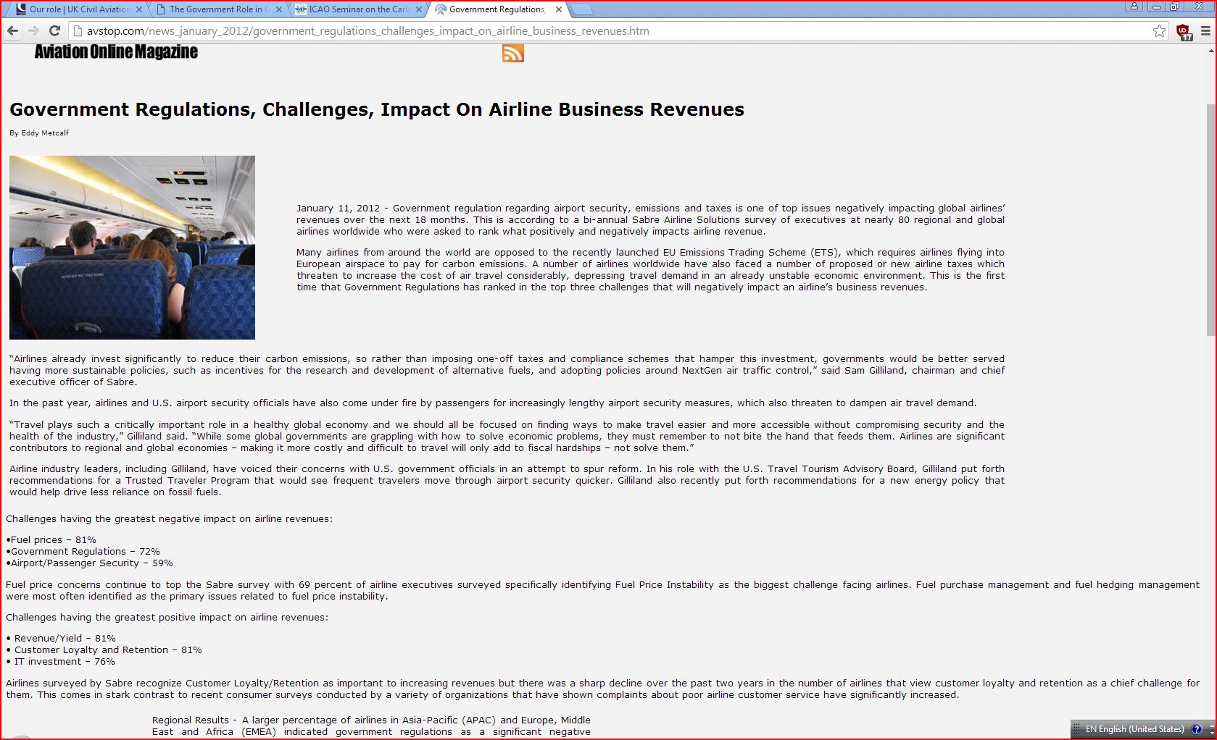
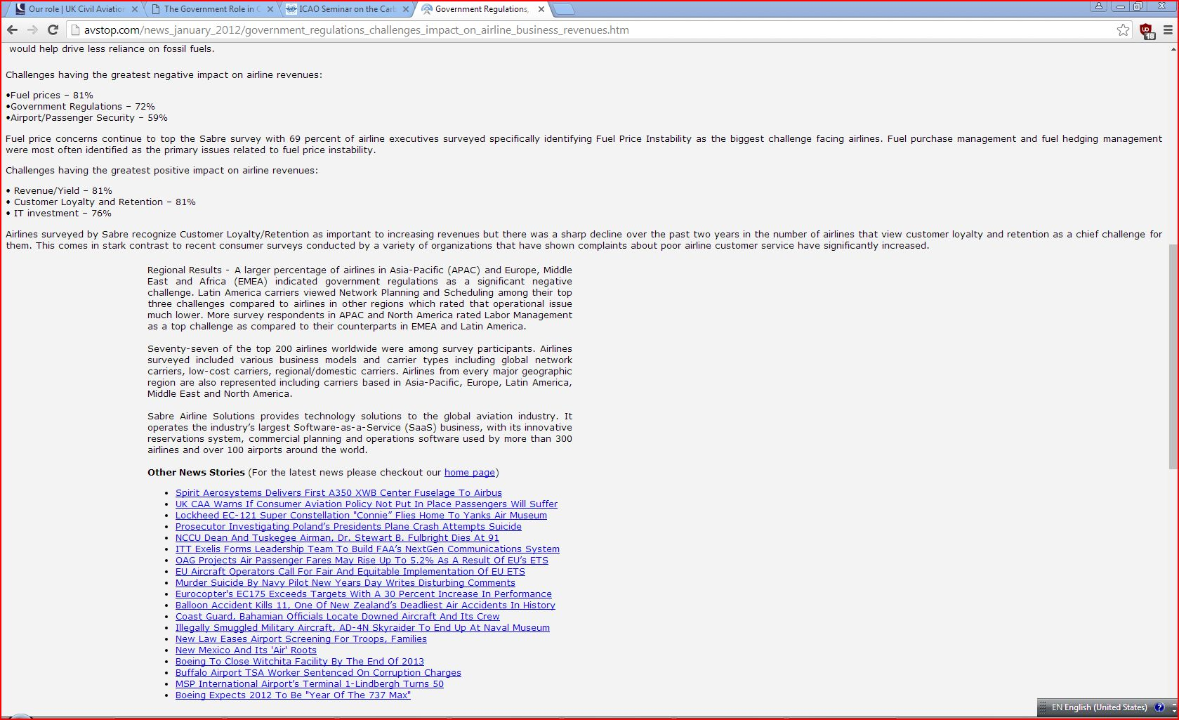
Political elements
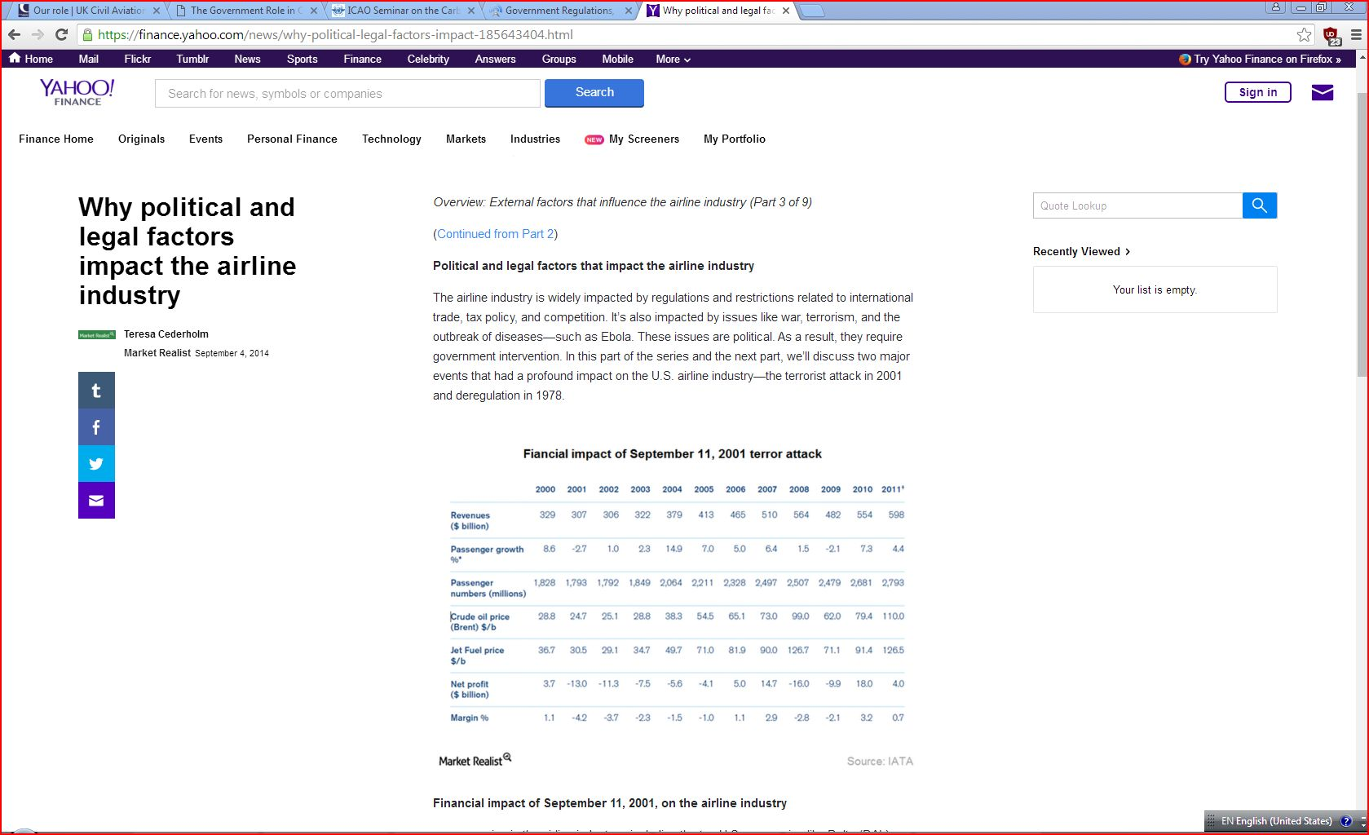
Market elements
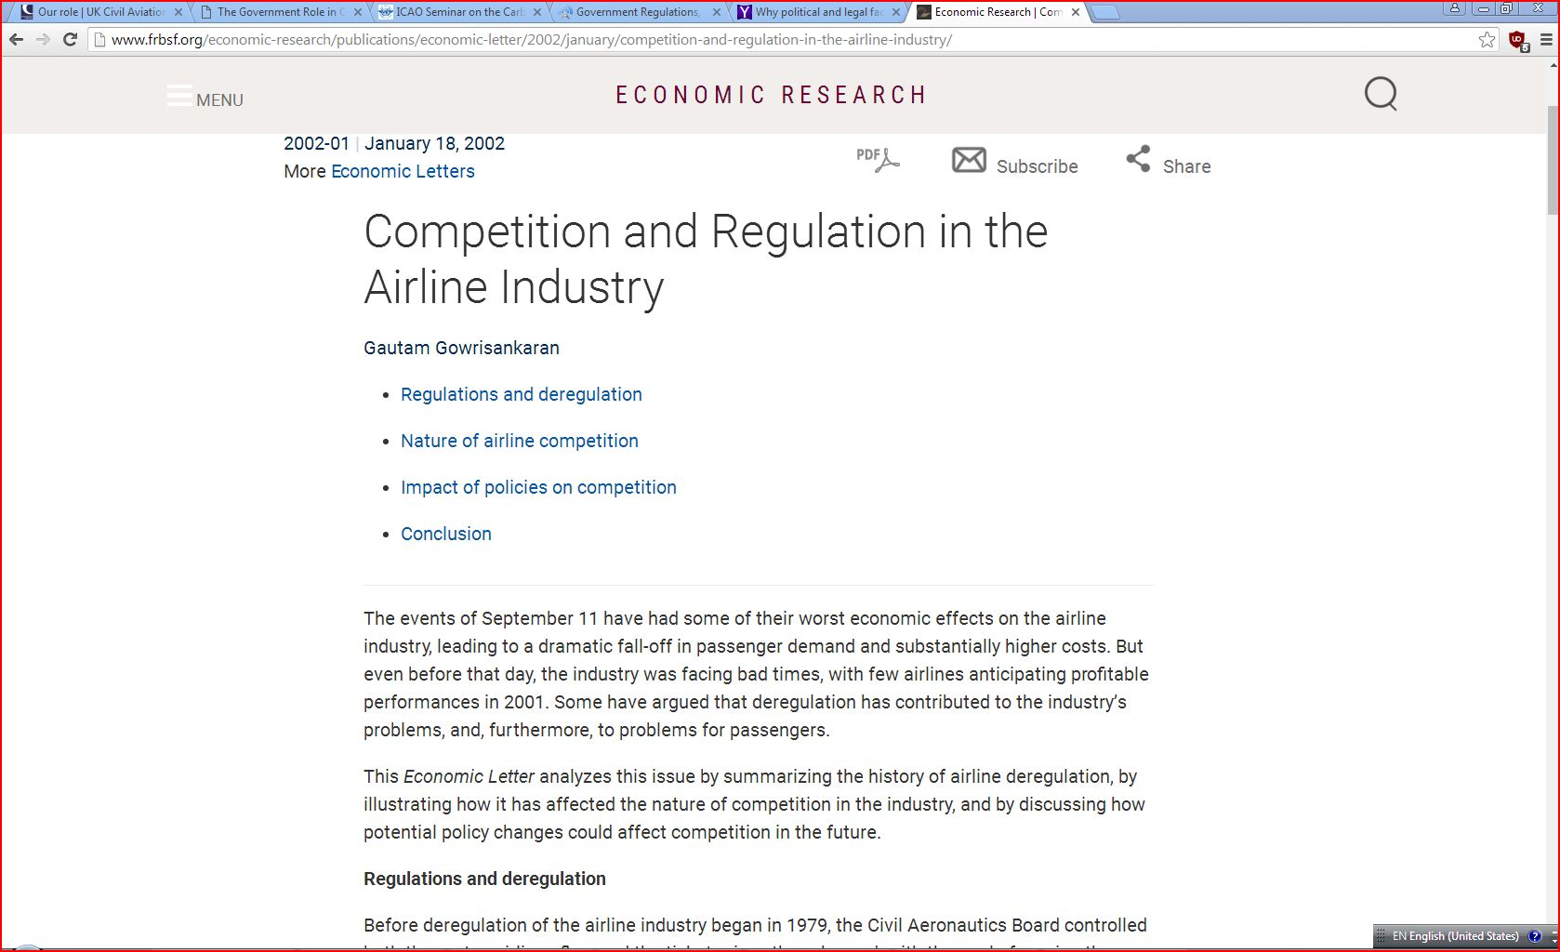
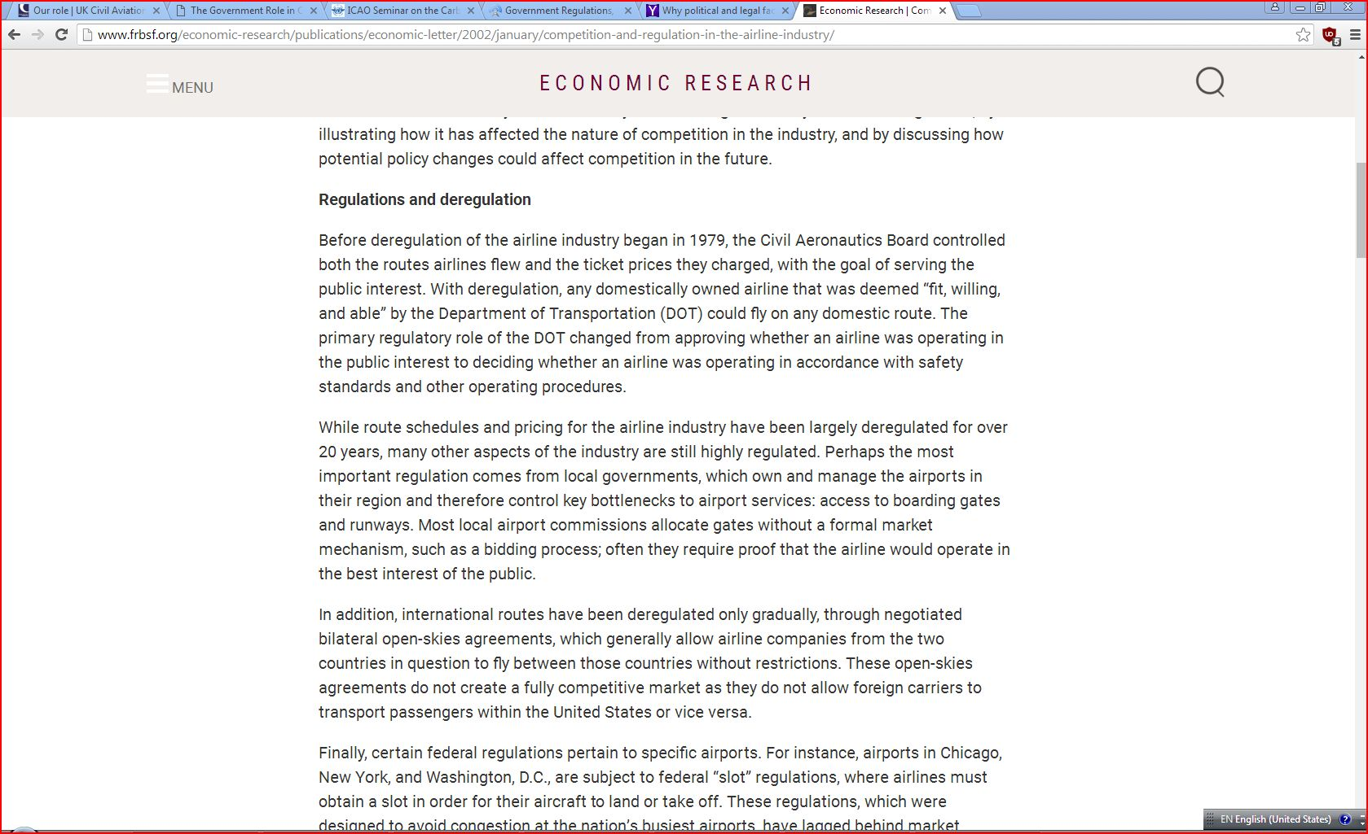
Rationale.
Government, market, politics as shown above has greatly influenced the regulation and deregulation of the aviation industries. In government, the top influence on airport security, emissions and taxes which affects and impact the industries and also impact global airlines revenue over years. The government out relation on how to control the impact of the green gases that is released to the environment by the aircraft industries. Technology influence the regulation and deregulation since it must move with the growth of technology. Government put rules and regulation that must be followed by aviation industries so as to reduce the negative effects. These technologies ensure there is healthy environment and help in easy and accessible travel without affecting the health of people and environment. Politics affects the industries since there is rise of terrorism that cause insecurity in the industries and regulations and deregulations are made to prevent these acts. Example one that happed in USA in 2001. Regulations ensure there is security in airport by providing security checks. On economic elements, there is deregulation of international routes which happen through negotiated bilateral talks and this allow the travelers to move without restrictions.
Learning Outcome #3 Interpret the specific contextual elements that shaped key aviation regulatory events, such as passage of the 1938 Civil Aeronautics Act and the 1978 Airline Deregulation Act.
Artifact 1
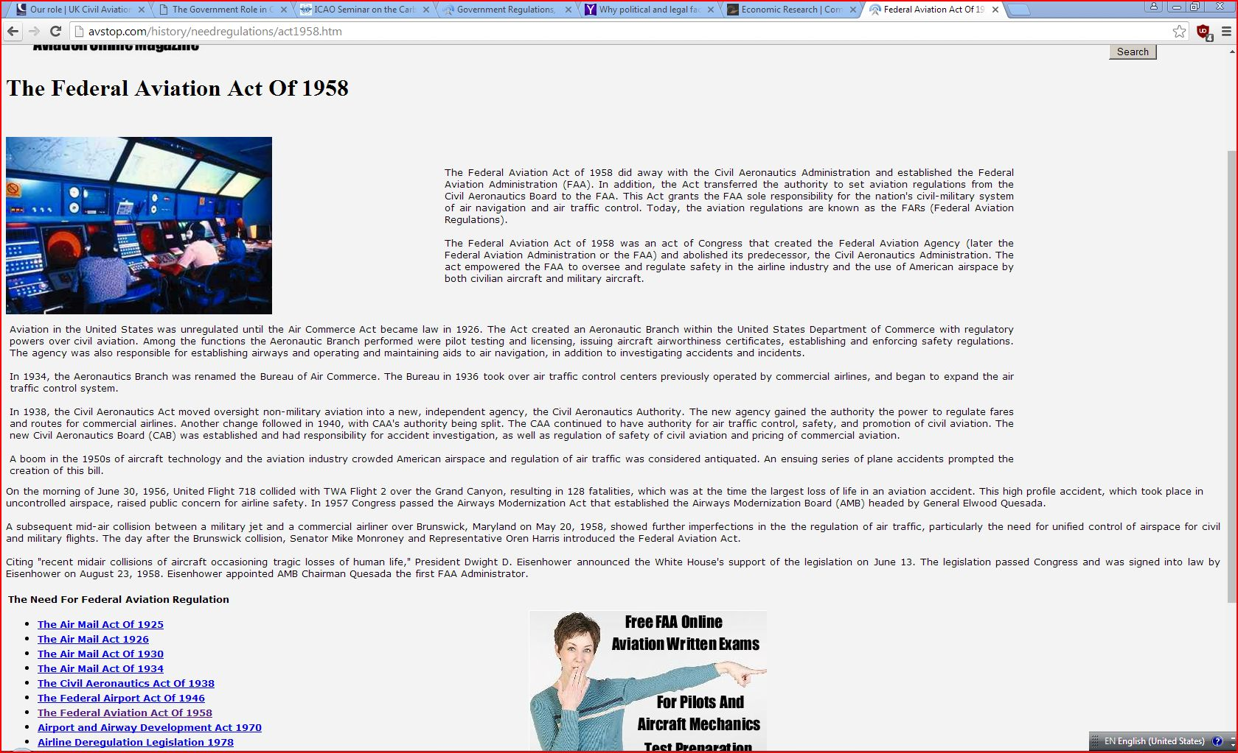
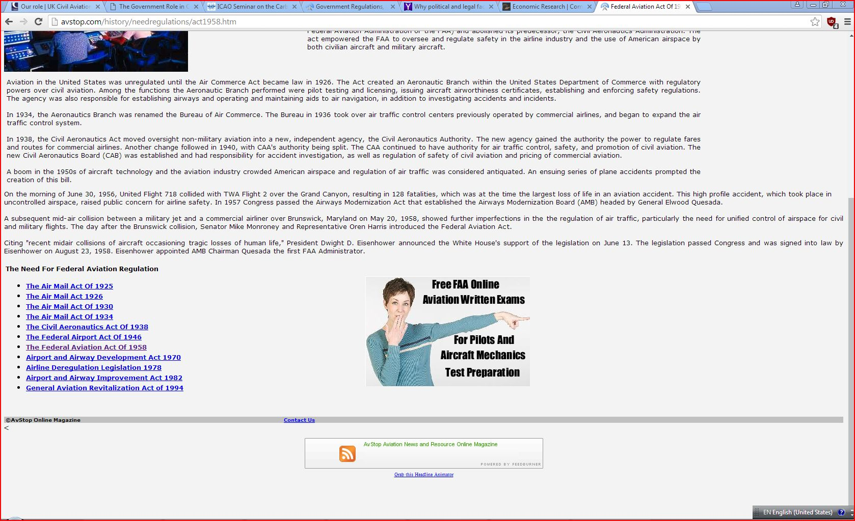

Rationale-The Federal Aviation Act of 1958, was an act by the U.S. Congress that created the Federal Aviation Administration. At first the Civil Aeronautics Board originally had the authority of setting aviation regulations. The goal and mission for the Federal Aviation Act of 1958 is to encourage safe air travel to keep people and property safe. It also provides regulation on preventing collisions, navigating, and identifying aircraft. This act played a vital role in aviation creating a safe and reliable environment
Learning Outcome #4 Identify the impacts of key aviation regulatory events on the commercial aviation and aerospace industry and the evolving context of aviation policy and regulation.
Artifact 1
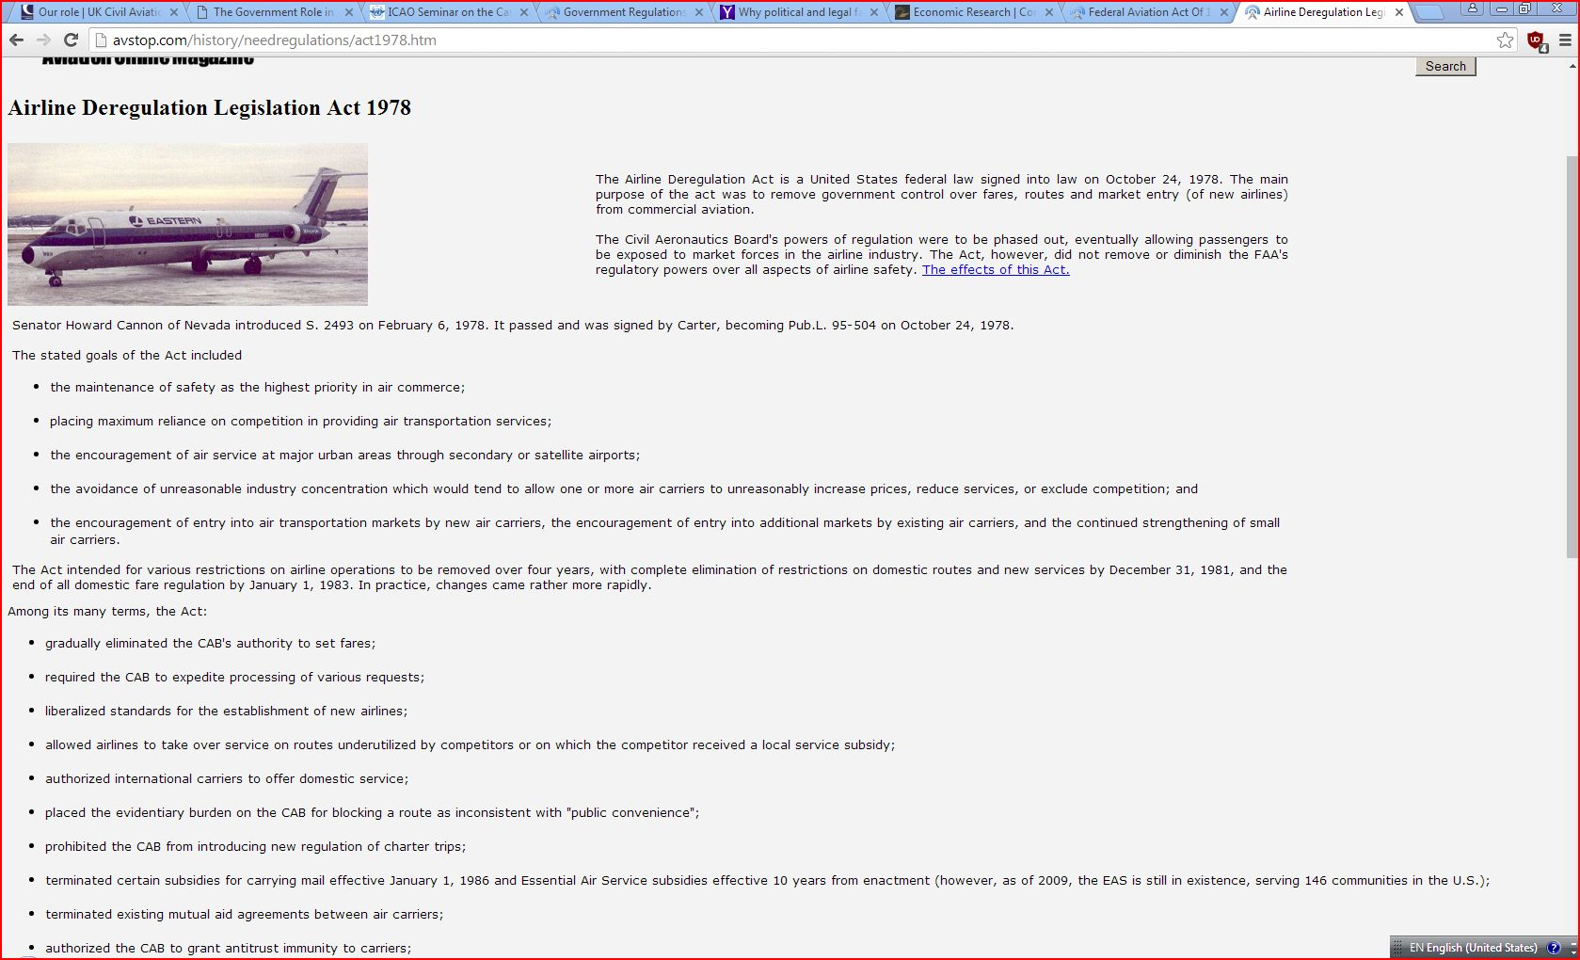
Artifact 2 cont.’ of 1
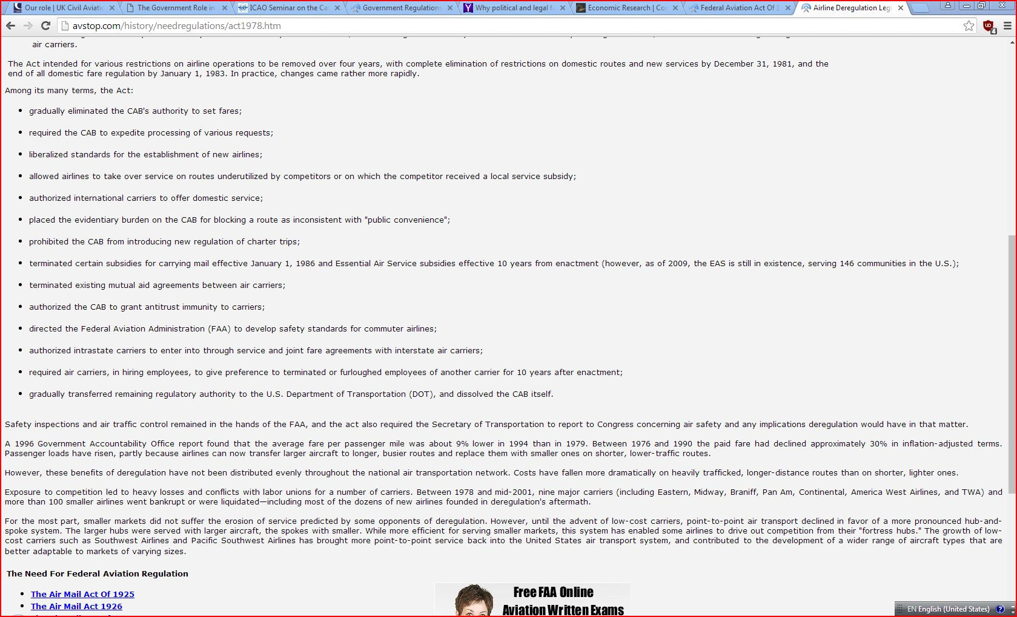
Rationale
Once jets started growing in the aviation industry in the 1950s, the industry grew dramatically. This growth wasn’t really a good thing considering there wasn’t regulations in place for the capacity. It was needed badly for a new deregulation. Airline employees were being ram and learning how to cope with the new large capacity as well as the passengers that travel. Air traffic control became out of control and air carriers were over loaded. All of these causes were more of a reason to create a new deregulation. This was good because it challenged new competition and gave aviation experiences with new markets since The Airline Deregulation Act helped since it stopped allowing airlines serve any given route they pleased on their own.
Learning Outcome #5 Identify historical and emerging contextual and regulatory continuities of probable relevance to current and future commercial aviation events and policy
Artifact 1
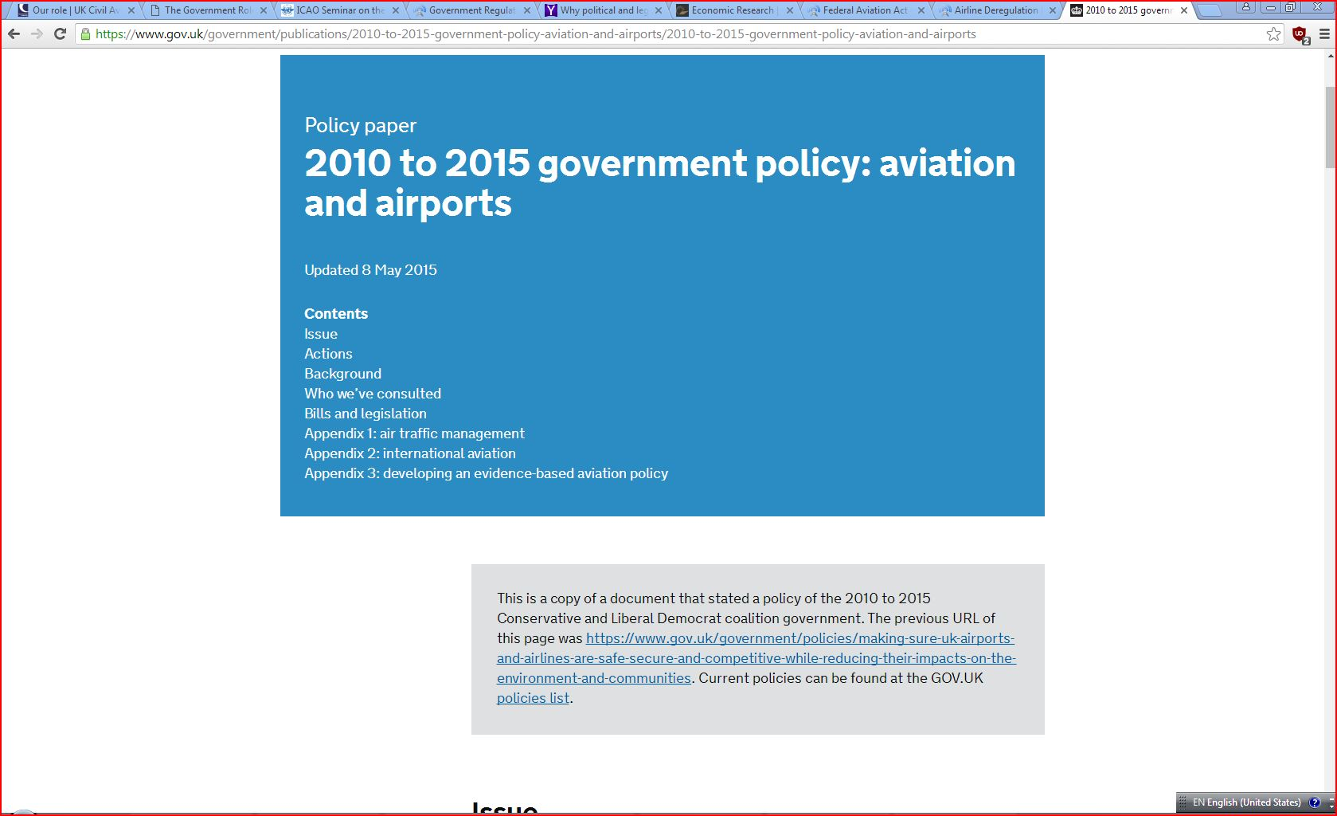
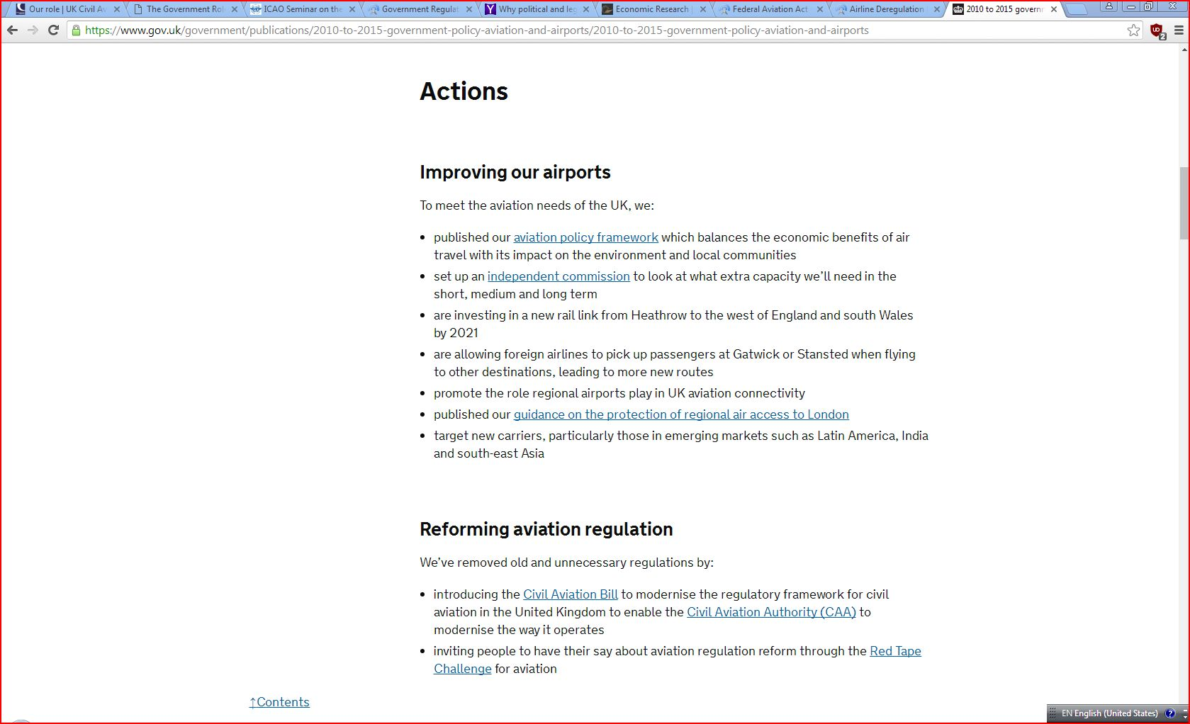
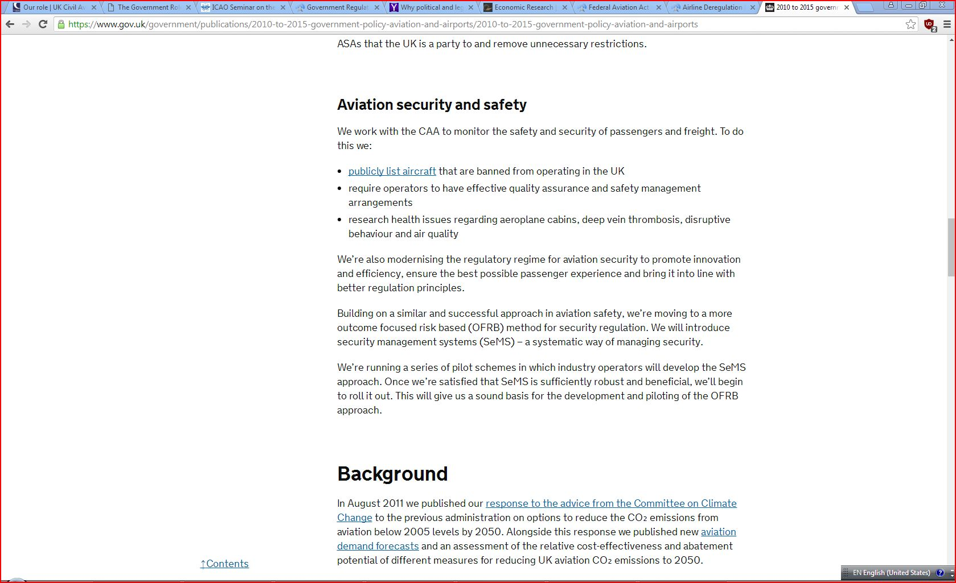
Artifacts 2
- https://www.gov.uk/government/consultations/draft-aviation-policy-framework
- https://www.gov.uk/government/organisations/airports-commission
- https://www.gov.uk/government/publications/public-service-obligation-regional-air-access-to-london
- http://www.caa.co.uk/

Rationale.
They make sure that the airport and the airline industries do have opportunity to provide domestic and international service so as to make the industry grow faster and also prosper globally. It has come up with ways to curb and mitigates the impact of environment pollution and other climate changes. It also ensured that the airline travel is secure and safe. It has done so by improving the airport through publication of aviation policy framework and also forms independent commission to ensure there is extra capacity need currently and in the future. There is also reforming aviation regulations such as civil Aviation Bill, Civil Aviation Authority which ensures it modernizes the way aviation operates.
Learning Outcome #6 Select and apply appropriate research and communication methodologies in the analyses and presentation of subjects of relevance to the objectives of this course.
The subject is marketing in the aviation industries.
Artifact 1
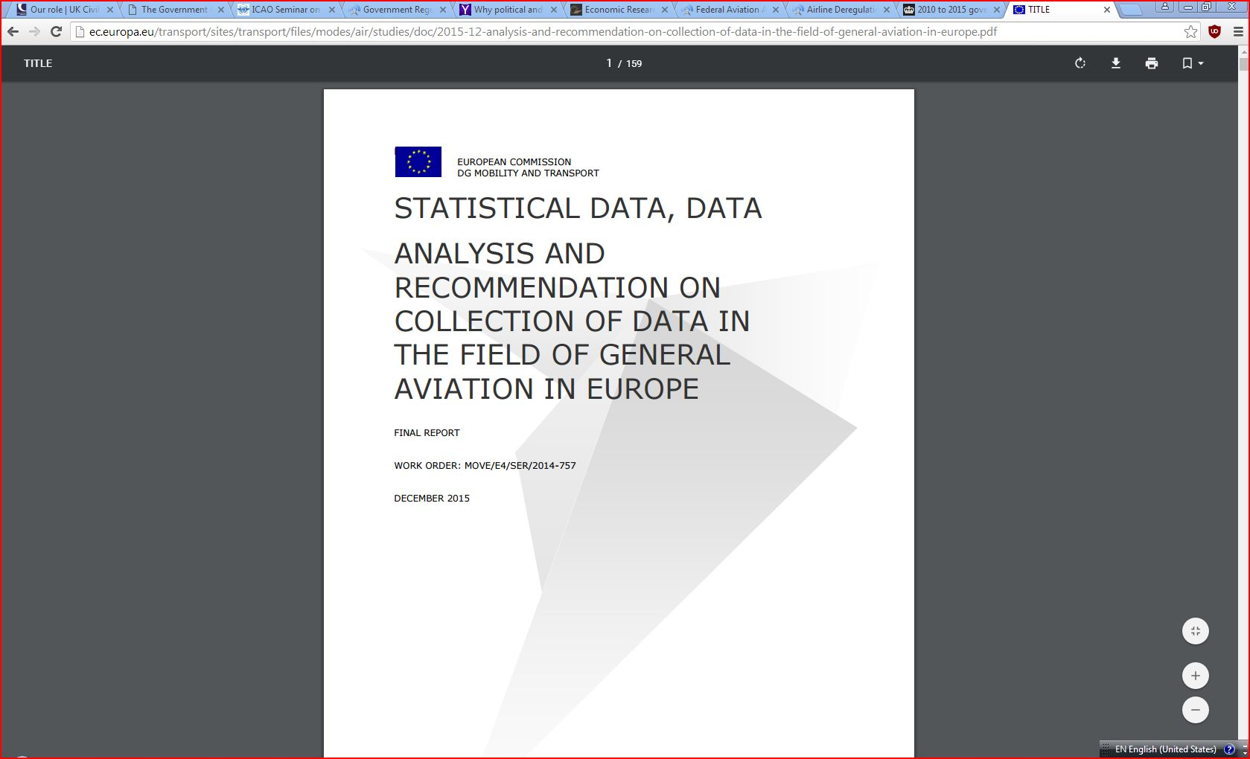
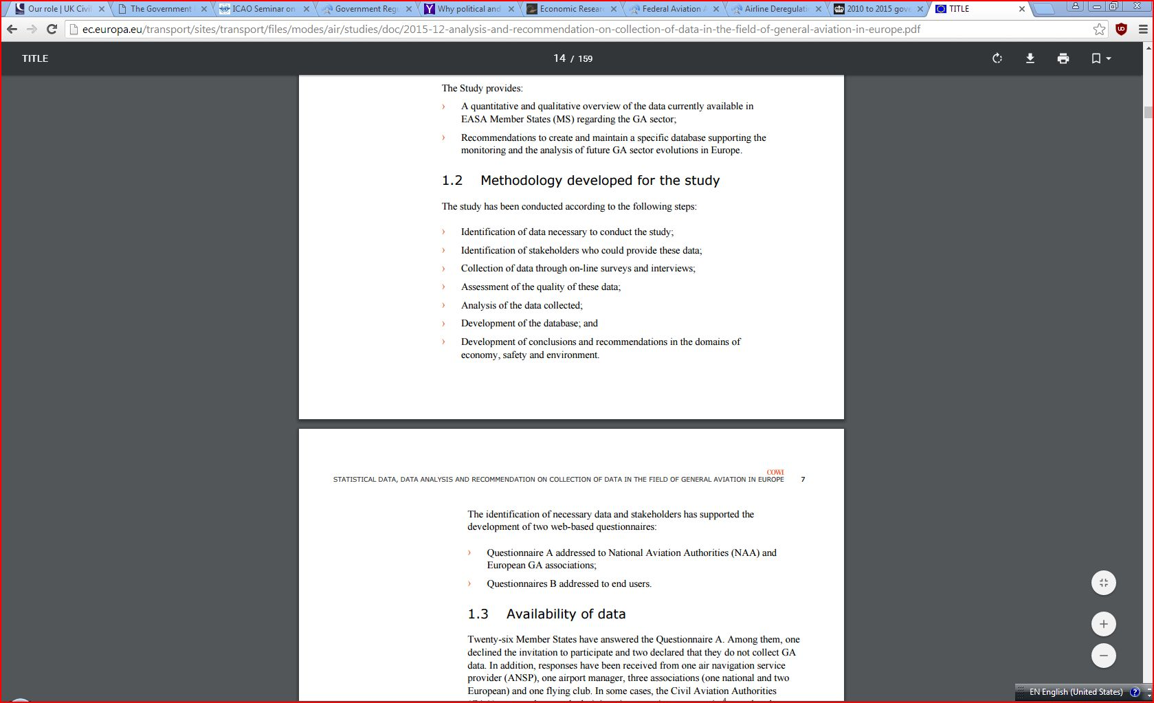
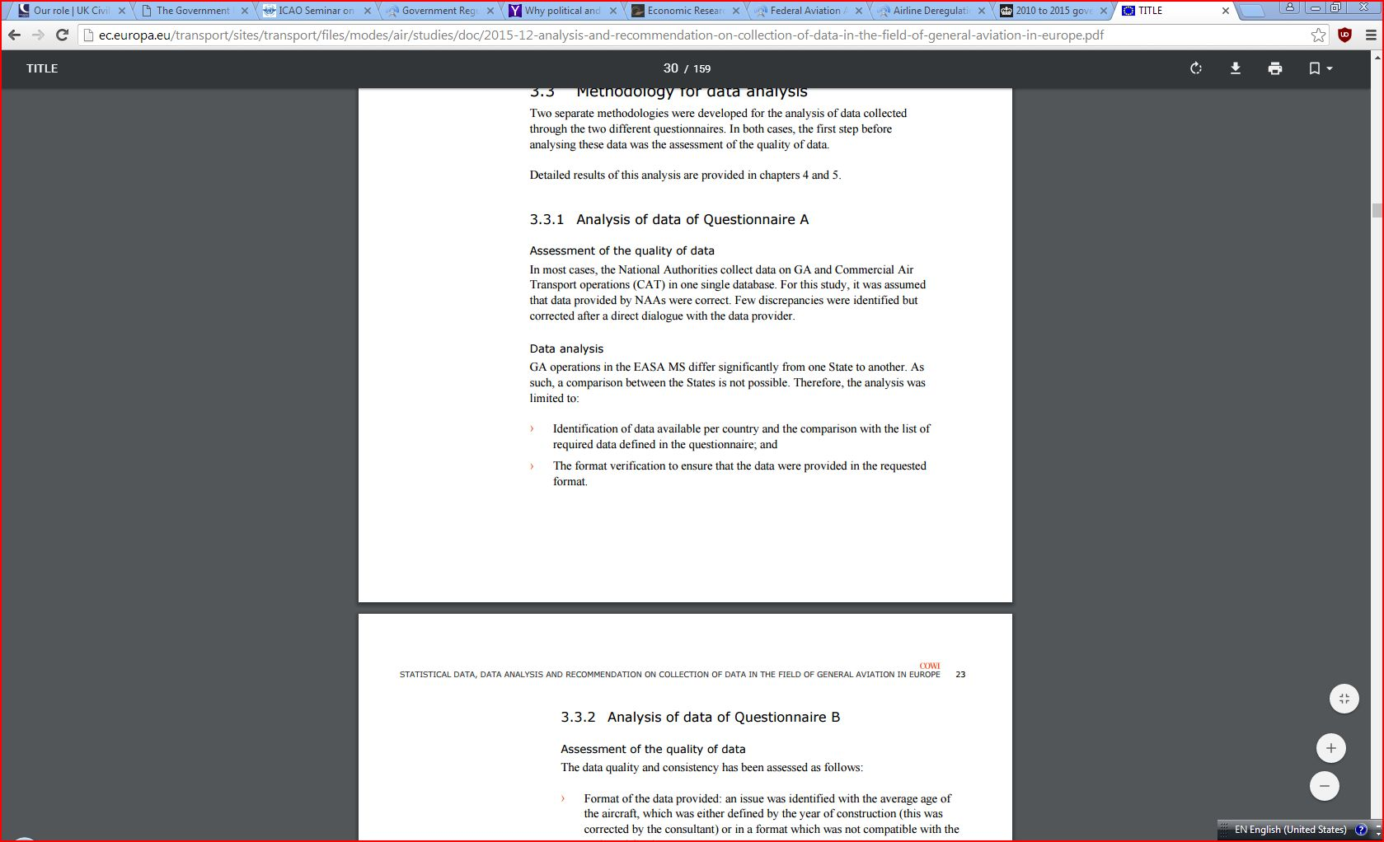
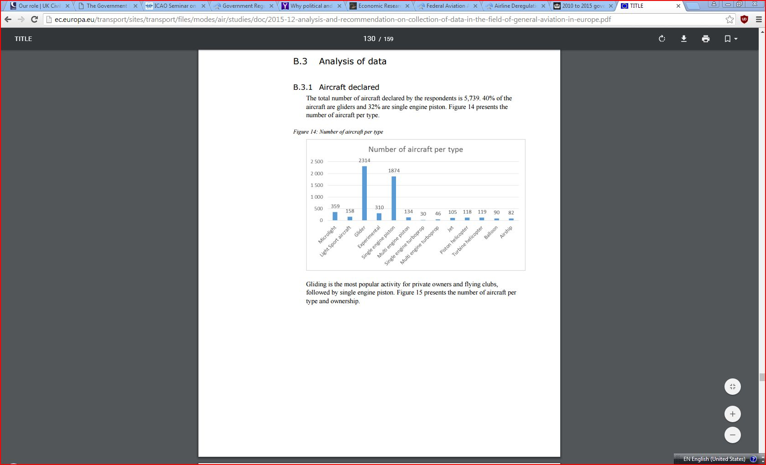
Rationale
The purpose of this research is to provide information about the general change in the in General Aviation and Remotely Piloted Aircraft System (RPAS). The aim is to bring change to the General Aviation Community by putting regulations and introduce flexible measure and also promoting safety regulations to ensure promotion of peace and avoiding the safety risks.
They collect data and analyze them on the accidents and incidences in a very systematic way through qualitative and quantitate methods. It also aim to capture missing statistical data on General Aviation with aim to provide recommendation for any missing data and eventually recommends how to develop the sector and improve the quality and safety sector and limiting negative impact on the environment. It considers the Environment and economic aspects and determine direct and indirect impacts in airport which is aerodromes, ground handling services, security services and the contribution to the Gross Domestic Product.
Learning Outcome #7 Review and explain the history of international aviation relations by focusing on the conferences, conventions and treaties that shaped and affected international agreements between nations in aviation matters.
Artifacts 1
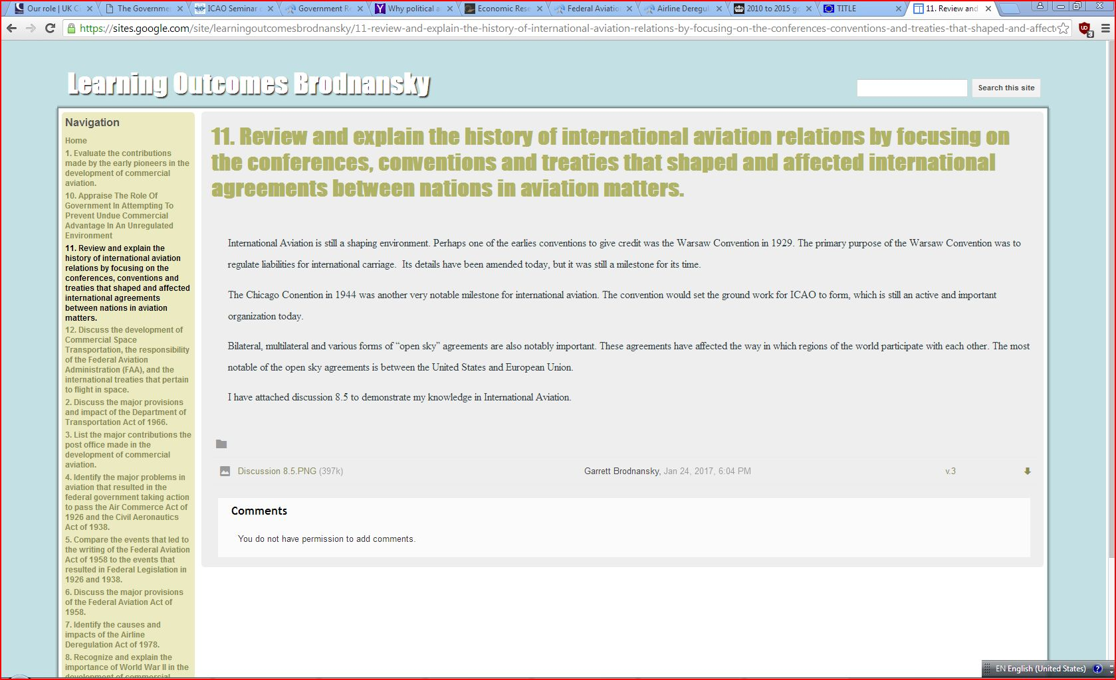
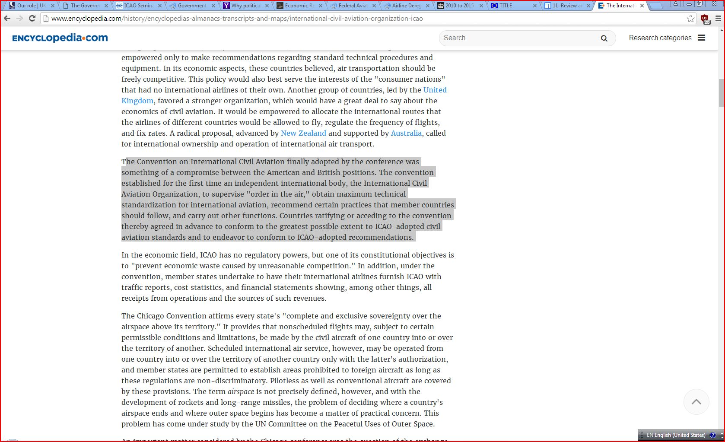

Artifacts 3

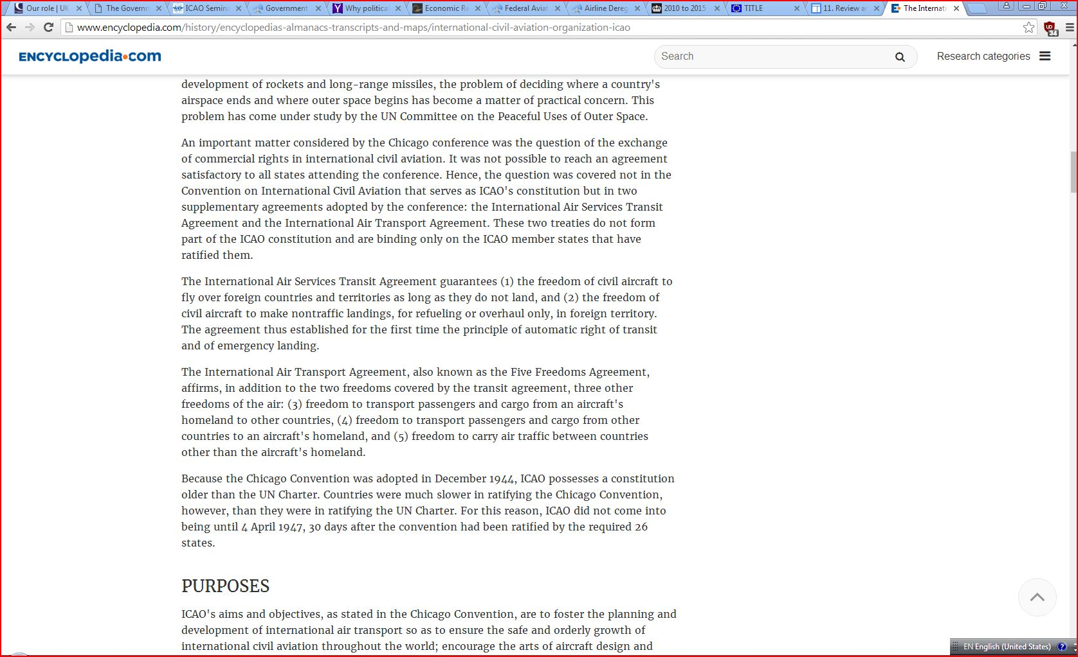
Rationale-This is aimed at shaping the environment in the aviation sector. The earliest convention was that of Warsaw Convention in 1929 which was to regulate liabilities for international carriage. Another one was one held in Chicago in 1944 which was a notable and monumental milestone in aviation industries internationally. These and other conventions have helped to shape the industry even to date. There is International Civil Aviation, ICAO and there was two supplementary agreements inform of a treaties which were binding to ICAO and countries that have ratified it even though they do not form part of ICAO’s constitution. They include the International Air Service Transit Agreement and International Air Transport. The former ensures there is freedom of civil aircraft which was to ‘fly over foreign countries and their territories as long as they do not land’ except for refueling and overhaul purposes. The latter which was known as ‘Five Freedom Agreement which ensures that there is freedom to transport cargos and passengers from homeland to another countries, ‘freedom to transport passangers and cargo form one other countries to an aircraft’s homeland and ‘freedom to carry air traffic between countries other than the aircrafts homeland.

